Lab 7-1 Setting Up and Configuring the Siebel Analytics Scheduler
Goals | To set up and configure the Siebel Analytics Scheduler.
Scenario | In order to submit jobs the Scheduler needs the Analytics Scheduler tables to be configured. You will create a database and ODBC data source for the Scheduler tables. The Scheduler tables will be created using Microsoft Query Analyzer, and will reside in a database named S_NQ_SCHED. Further Scheduler configuration is done from the Job Manager found in the Siebel Analytics Administration Tool.
Time | 10 – 15 minutes
Environment | 
Instructions:
- Create a new database to hold the Scheduler tables using Enterprise Manager.
  - Select Start > Programs > Microsoft SQL Server > Enterprise Manager.
  - Expand the tree on the left to view the Databases folder.
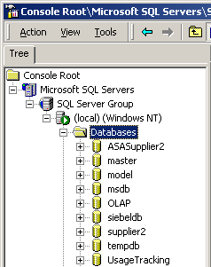
  - Right-click the Databases folder and select New Database.
  - Enter S_NQ_SCHED as the database name.
  - Click OK.
  - Verify that the new database was created under the database folder. Your screen should look as follows:
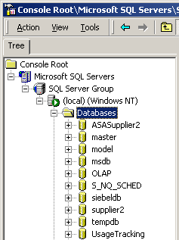
  - Minimize Enterprise Manager.
- Create an ODBC data source that points to the new S_NQ_SCHED database.
  - In the ODBC Data Source Administrator dialog box, click the System DSN tab.
  - Click Add.
  - Select the SQL Server driver from the list.
  - Click Finish.
  - In the Create a New Data Source to SQL Server dialog box, enter the following values:
Name | S_NQ_SCHED
Server | (local)
  - Click Next.
  - Select With SQL Server authentication using a login ID and password entered by the user.
  - Enter the following values:
Login ID | sa
Password | <none>
  - Click Next.
  - Select the check box for Change the default database to, and select S_NQ_SCHED from the drop-down list.
  - Click Next.
  - Click Finish.
  - Click Test Data Source and verify that the test completes successfully.
  - Click OK.
  - Click OK.
  - Click OK to close the ODBC Data Source Administrator.
- Create the tables used by the Siebel Analytics Scheduler.
  - Select Start > Programs > Microsoft SQL Server > Query Analyzer.
  - In the Connect to SQL Server dialog box, enter the following:
Login Name | sa
Password | <none>
  - Click OK.
  - Select the S_NQ_SCHED database from the drop-down list.
  - Select File > Open.
  - In the Open Query File dialog box, navigate to C:\SiebelAnalytics\Schema and select SAJOBS.MSSQL.sql. This script is provided as part of the Siebel Analytics installation.
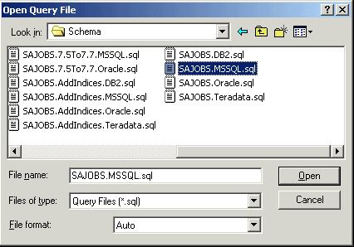
  - Click Open.
  - Select Query > Execute to run the script.
  - Verify that you receive the following message in the message pane:
The command(s) completed successfully.
  - Minimize Query Analyzer.
- Verify that the Siebel Analytics Server service is running.
- Set the Scheduler configuration options in the Job Manager.
  - Open ServArchAdv.rpd in online mode using the Siebel Analytics Administration Tool.
  - Select Manage > Jobs.
  - In the Job Manager, select File > Configuration Options.
  - Select local as the Machine Name.
  - Click OK.
  - In the Job Manager Configuration dialog box, enter the following values:
Database Type | ODBC 3.5
Data Source Name | S_NQ_SCHED
User Name | sa
Password | <leave blank>
Administrator Name | Administrator
Administrator Password | <leave blank>
Confirm Password | <leave blank>
  - Click OK.
  - Click OK to confirm that you need to restart the Siebel Analytics Scheduler service.
  - Select File > Exit Job Manager.
- Start the Siebel Analytics Scheduler service.
  - If necessary, select Start > Programs > Administrative Tools > Services to bring up the Services window.
  - Right-click Siebel Analytics Scheduler and select Start.
  - Minimize the Services window.
Lab 7-2 Exploring the Scheduler Tables
Goals | To query the Scheduler tables to get a better understanding of the information stored in them.
Scenario | You will look at the information in the tables before a job is scheduled and again after a job has been run to see what information is stored and where it can be accessed.
Time | 10 – 15 minutes
Instructions:
- Query the tables used by the Siebel Analytics Scheduler
  - In Query Analyzer, select the S_NQ_SCHED database from the Object Browser on the left.
  - Expand the S_NQ_SCHED database icon and then expand the User Tables folder and verify you can see the tables created during the last lab.
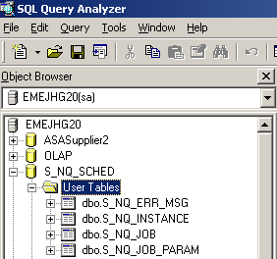
  - Right-click the S_NQ_JOB table and select Open.
  - How many records are displayed?
  - Close the Open Table window.
  - Right-click the S_NQ_INSTANCE table and select Open.
  - List the columns in this table:
  - Close the Open Table window.
  - Inspect the remaining user tables in this database.
  - Minimize Query Analyzer.
- Create a request in Siebel Answers to be used in a scheduled job.
  - Log in to Siebel Analytics Web as Administrator with no password.
  - Click Answers.
  - Click the SupplierSales subject area.
  - Create a query with Customers.Region, Customers.Sales Rep, and SalesFacts.Dollars. 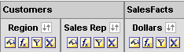
  - Save this request in My Folder with a Name of Sales by Region.
  - Click the Results tab to verify the request.
- Create and run a scheduled job from Siebel Delivers.
  - Click Delivers to navigate to the Siebel Delivers start page.
  - Click Show Current iBots.
  - Do the results match what you found by querying the database tables from Query Analyzer?

  - Use the back arrow in the browser to return to the start page.
  - Click Create New iBot to create a new iBot.
  - Click the Schedule tab and note the iBot will run immediately.
  - Click the Delivery Content tab and enter Scheduler Lab as the Headline.
  - Click Select Content and then select Sales by Region in the Choose Delivery Content dialog box.
  - Click OK.
  - Click the Save icon.
  - Enter Scheduler Lab as the iBot Name.
  - Click Save.
  - Click Answers and notice there is now an Alerts link with a red flag at the top of the screen.
  - Click Alerts!
  - Click View this Alert.
  - Close the window.
- Query the tables used by the Siebel Analytics Scheduler.
  - In Query Analyzer, if necessary expand the S_NQ_SCHED database icon and the User Tables folder.
  - Right-click S_NQ_JOB table and select Open.
  - How many records are displayed?
  - When was the last time this job was run and when will it run next?
  - Close the Open Table window.
  - Right-click S_NQ_INSTANCE and select Open.
  - How many records are displayed?
  - Close the Open Table window.
  - In Siebel Analytics Web, navigate back to Delivers and click Show Current iBots.
Note: It may be necessary to log back in to Siebel Analytics Web.
  - Click the iBot named Scheduler Lab.
  - Click the Schedule tab and select Start Immediately.
  - Click the Save icon.
  - Leave the name the same and click Save.
  - In Query Analyzer, right-click S_NQ_INSTANCE and select Open.
  - How many records are displayed?

  - Explain the role of the S_NQ_INSTANCE table.

  - Inspect the remaining User Tables in this database.
  - Minimize Query Analyzer.
Solutions 7-2 Exploring the Scheduler Tables
Answers
1.d. How many records are displayed?
0
1.g. List the columns in this table:
JOB_ID, INSTANCE_ID, STATUS, BEGIN_TS, END_TS, EXIT_CODE, DELETE_FLG, ERROR_MSG_FLG
3.c. Do the results match what you found by querying the database tables from Query Analyzer?
Yes, there are currently no jobs.
4.c. How many records are displayed?
1
4 d. When was the last time this job was run and when will it run next?
LAST_RUNTIME_TS will vary and there will be no next run time since it was not a reoccurring job.
4.g. How many records are displayed?
1
4.o. How many records are displayed?
2
4.p. Explain the role of the S_NQ_INSTANCE table.
It contains a record for each instance of each job run.
Lab 7-3 Renaming Scheduler Tables
Goals | To change the Scheduler table names and have the Scheduler be able to use the new tables.
Scenario | Your database administrator has set naming conventions for all administrative tables for the project. The Scheduler currently does not meet these naming conventions, so you need to change the Scheduler table names to meet the project requirements.
Time | 10 – 15 minutes
Instructions:
- Shut down the Siebel Analytics Scheduler service.
- Rename the Scheduler tables using Microsoft Enterprise Manager.
  - In Enterprise Manager, if necessary expand the tree on the left to view the Databases folder and expand the Databases folder.
  - Expand the S_NQ_SCHED database.
  - View the table list by clicking the Tables icon under the S_NQ_SCHED database.
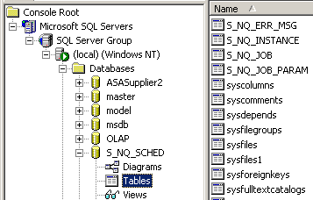
  - Rename the S_NQ_ERR_MSG table ADMIN_SCHED_ ERR_MSG.
    - Right-click the S_NQ_ERR_MSG table and select Rename.
    - Enter ADMIN_SCHED_ ERR_MSG as the new name.
  - The following warning appears. Click View Dependencies.
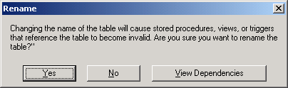
  - There are no dependencies on these tables. Click Close.
  - Click Yes to allow the rename to complete.
  - Click OK to acknowledge the name change.
  - Repeat the above steps for the S_NQ_INSTANCE, S_NQ_JOB, and S_NQ_JOB_PARAM tables, changing S_NQ to ADMIN_SCHED in each case. The tables should appear as follows:
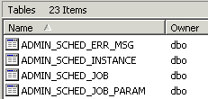
  - Close Enterprise Manager.
- Change the table names used by the Analytics Scheduler.
  - Start the Windows registry editor.
    - Select Start > Run.
    - In the Run dialog box, enter regedit.
    - Click OK.
  - In the registry, navigate to HKEY_LOCAL_MACHINE\SOFTWARE\Siebel Systems, Inc.\Siebel Analytics\Scheduler\7.8.
  - Right-click the 7.8 folder and select New > Key.
  - Enter the name DB Column Names for the new key.
  - Right-click DB Column Names and select New > String Value.
  - Name the string value TABLE_JOBS.
  - Double-click the TABLE_JOBS string value.
  - In the Edit String dialog box, enter ADMIN_SCHED_JOB as the value data.
  - Click OK.
  - Create a string value for each entry below. The value for data is the table name being used currently in the database.
Strin Value Name | Data
TABLE_INSTANCES | ADMIN_SCHED_INSTANCE
TABLE_PARAMS | ADMIN_SCHED_JOB_PARAM
TABLE_ERRMSGS | ADMIN_SCHED_ERR_MSG
  - When you are done, the string values should appear as follows:
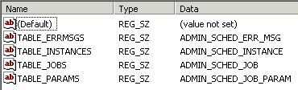
  - Select Registry > Exit to close the Registry Editor.
- Start the Siebel Analytics Scheduler service.
- Test the Scheduler by resubmitting a job from Siebel Delivers.
  - If necessary, log in to Siebel Analytics Web as Administrator with no password.
  - Click Delivers to navigate to the Siebel Delivers start page.
  - Click Show Current iBots from the start page.
  - Click the iBot named Scheduler Lab.
  - Click the Schedule tab and select Start Immediately.
  - Click the Save icon.
  - Leave the name the same and click the Save button.
- Query the tables used by the Siebel Analytics Scheduler
  - In Query Analyzer, select the S_NQ_SCHED database from the Object Browser on the left.
  - If necessary, expand the S_NQ_SCHED database icon and then expand the User Tables folder.
  - Right-click the ADMIN_SCHED_INSTANCE table and select Open.
  - How many records are displayed?
  - Did the table name changes take effect?
- Log out of Siebel Answers and close the browser window.
Solutions 7-3 Renaming Scheduler Tables
Answers
6.d. How many records are displayed?
3
6.e. Did the table name changes take effect?
Yes, since before there were only two instances and now there are three in the renamed table.

